MJ Marine Ltd - Privacy Policy (Rev.01 – May 2018)

MJ Marine Ltd receive, collect and store any information you enter on our website or provide us in any other way. In addition, we collect the Internet protocol (IP) address used to connect your computer to the Internet; e-mail address; computer and connection information. We use the ‘Visitor Analytics’ software tool to measure and collect session information, including page response times, length of visits to certain pages, page interaction information, and methods used to browse away from the page. (More details are contained about ‘Visitor Analytics’ at the end of this policy.

When you contact us via our website, we collect personal information you give us such as your name, address and email address. This personal information will only be used to respond to the specific enquiry and for any ongoing necessary dialogue between ourselves.

We collect such Non-personal and Personal Information for the following purposes:
- To provide and operate the Services;
- To provide our Users with ongoing customer assistance and technical support;
- To be able to contact our Visitors and Users with general or personalized service-related notices and promotional messages;
- To create aggregated statistical data and other aggregated and/or inferred Non-personal Information, which we may use to provide and improve our services;
- To comply with any applicable laws and regulations.

Our company website is hosted on the Wix.com platform. Wix.com provides us with the online platform that allows us to promote our services to you. Your data may be stored through Wix.com’s data storage, databases and the general Wix.com applications. They store your data on secure servers behind a firewall.
We may contact you to troubleshoot problems with your account, to resolve a dispute, to collect fees or monies owed, to send updates about our company, or as otherwise necessary to contact you to enforce our User Agreement, applicable national laws, and any agreement we may have with you. For these purposes we may contact you via email, telephone, text messages, and postal mail.
Cookies are small pieces of data stored on a site visitor's browser, usually used to keep track of their movements and actions on a site. Cookies are used on the mjmarineltd.com website as they are on every site built by Wix. The cookies used may include some or all of those detailed in the table below.

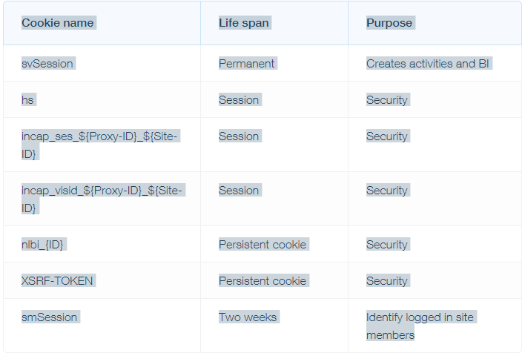

You can control and/or delete cookies as you wish by checking your browser settings on each device - for details, see aboutcookies.org.
If you don’t want us to process your data anymore, please contact us at: mjmarine@mikejubb.karoo.co.uk

We reserve the right to modify this privacy policy at any time, so please review it frequently. Changes and clarifications will take effect immediately upon their posting on the website. If we make material changes to this policy, we will notify you here that it has been updated, so that you are aware of what information we collect, how we use it, and under what circumstances, if any, we use and/or disclose it.

If you would like to: access, correct, amend or delete any personal information we have about you, you are invited to contact us at [your email] or send us mail to: mjmarine@mikejubb.karoo.co.uk

Visitor Analytics
Visitor Analytics is a simple website analytics service which measures the traffic and visitors' general details of the customers' websites. Collecting these statistics, a website can make their visitors' experience better (e.g. which pages they visit and when, where they are approximately located, where does a user land first or if they are coming from a specific referral).
Basically, as a website owner using Visitor Analytics, we are using cookies to collect data about visitors' device type and screen size, approximate location, browser, OS, page visits, bounce rate, conversions and popular content on the website. All this data is pseudonymized and Visitor Analytics will never use the collected data to identify individual users or to match it with additional information on an individual user. Each visitor has control over the cookies placement.

How to control cookies
You can control and/or delete cookies as you wish by checking your browser settings on each device - for details, see aboutcookies.org.
For further information, please check Visitor Analytics’ Terms Of Use and Cookie Information

